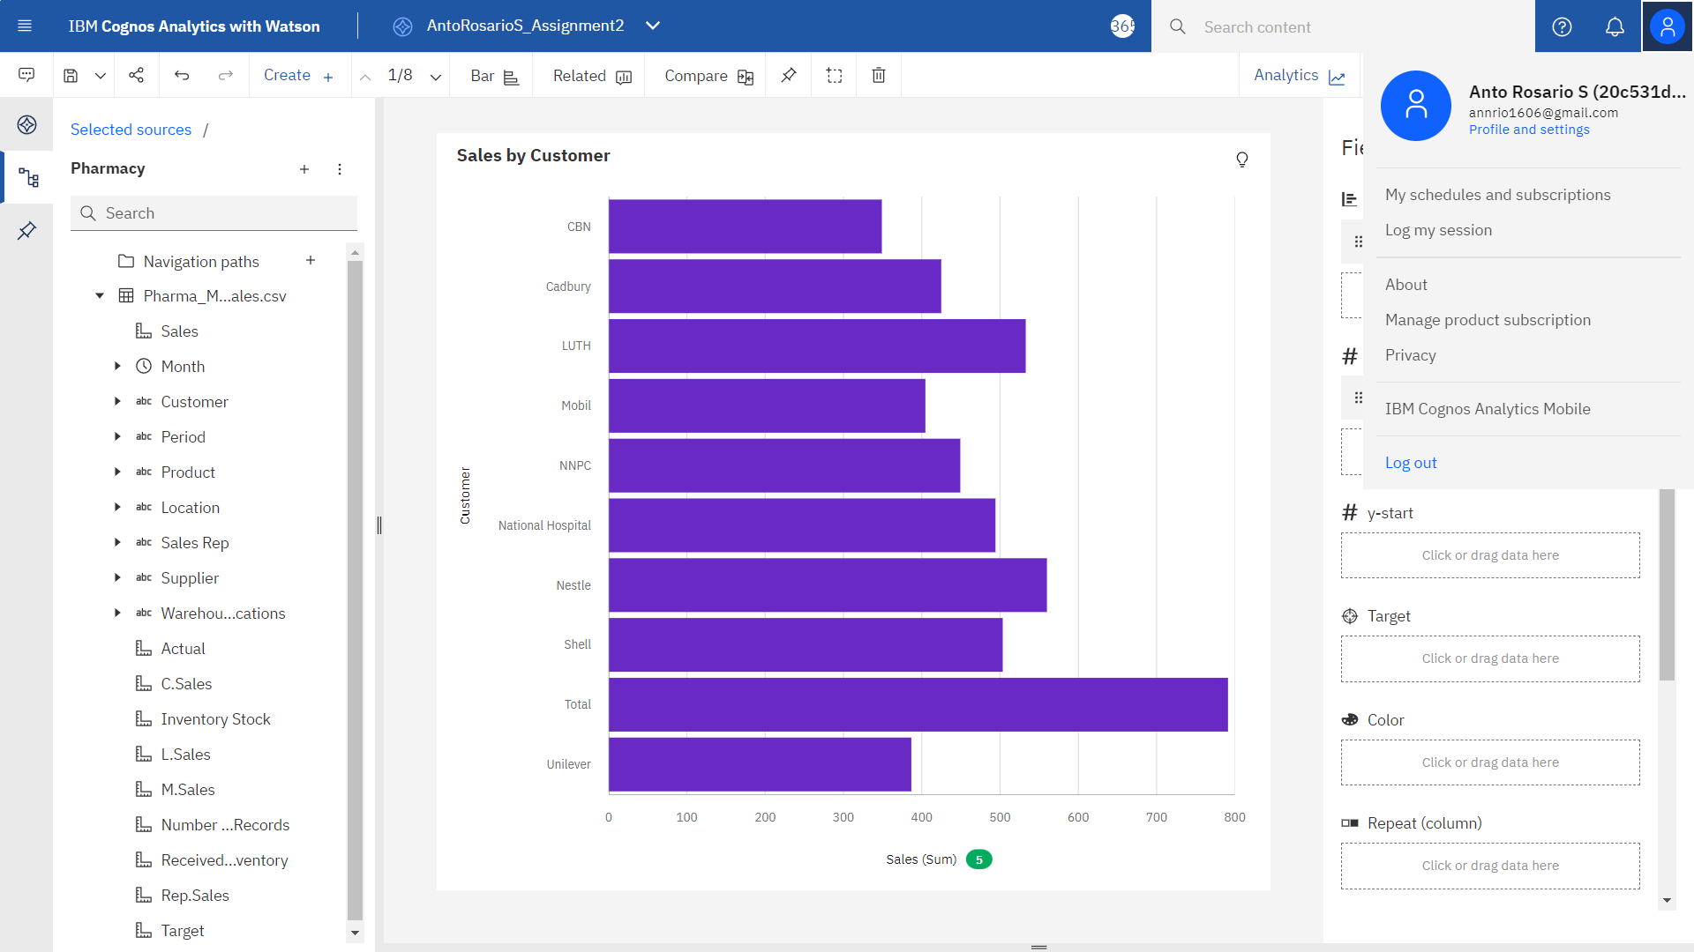

<https://us3.ca.analytics.ibm.com/bi/?perspective=explore&pathRef=.my_folders%2FAntoRosarioS_Assignment2&subView=model00000183ccf5c96e_00000000>

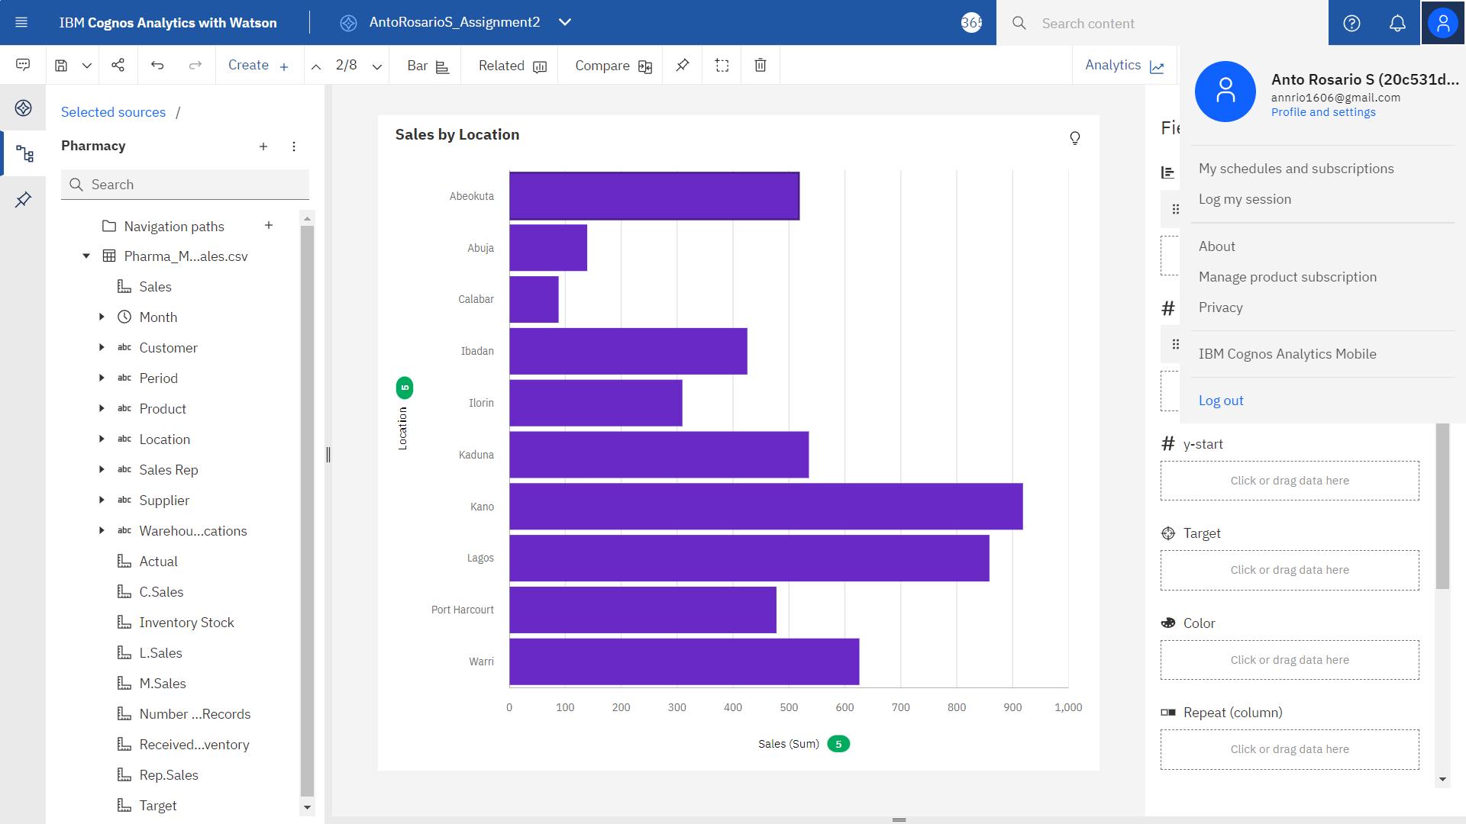

<https://us3.ca.analytics.ibm.com/bi/?perspective=explore&pathRef=.my_folders%2FAntoRosarioS_Assignment2&subView=model00000183ccf67465_00000004>

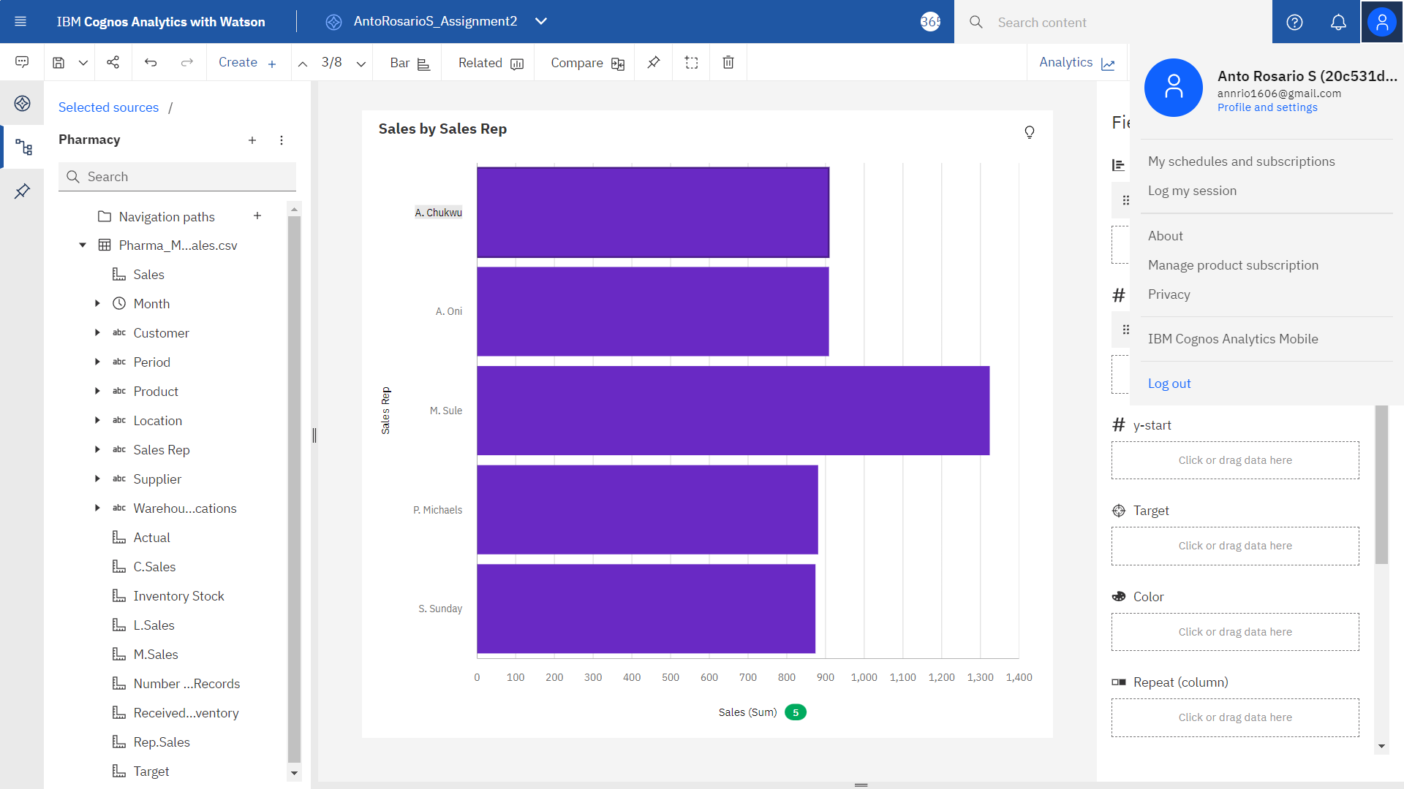

<https://us3.ca.analytics.ibm.com/bi/?perspective=explore&pathRef=.my_folders%2FAntoRosarioS_Assignment2&subView=model00000183ccf86ff3_00000004>

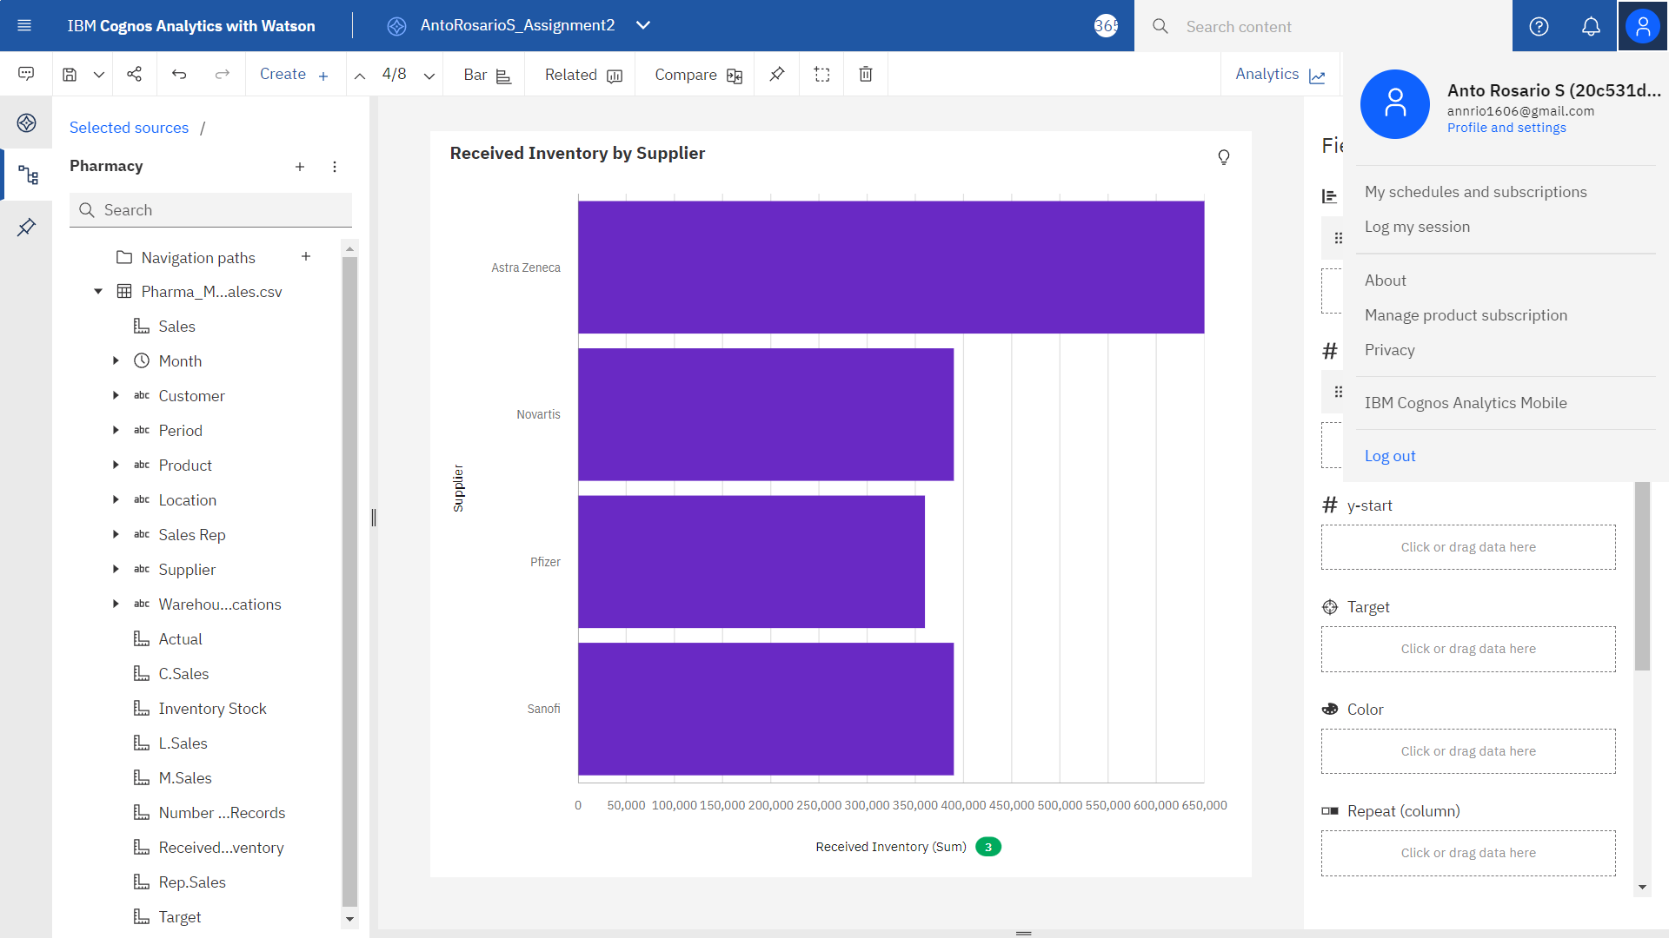

<https://us3.ca.analytics.ibm.com/bi/?perspective=explore&pathRef=.my_folders%2FAntoRosarioS_Assignment2&subView=model00000183ccf8804c_00000004>

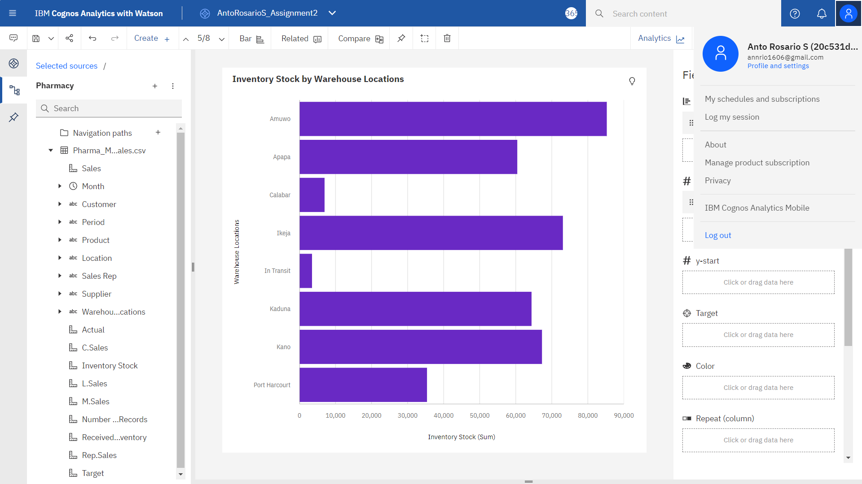

<https://us3.ca.analytics.ibm.com/bi/?perspective=explore&pathRef=.my_folders%2FAntoRosarioS_Assignment2&subView=model00000183ccf9b52b_00000004>

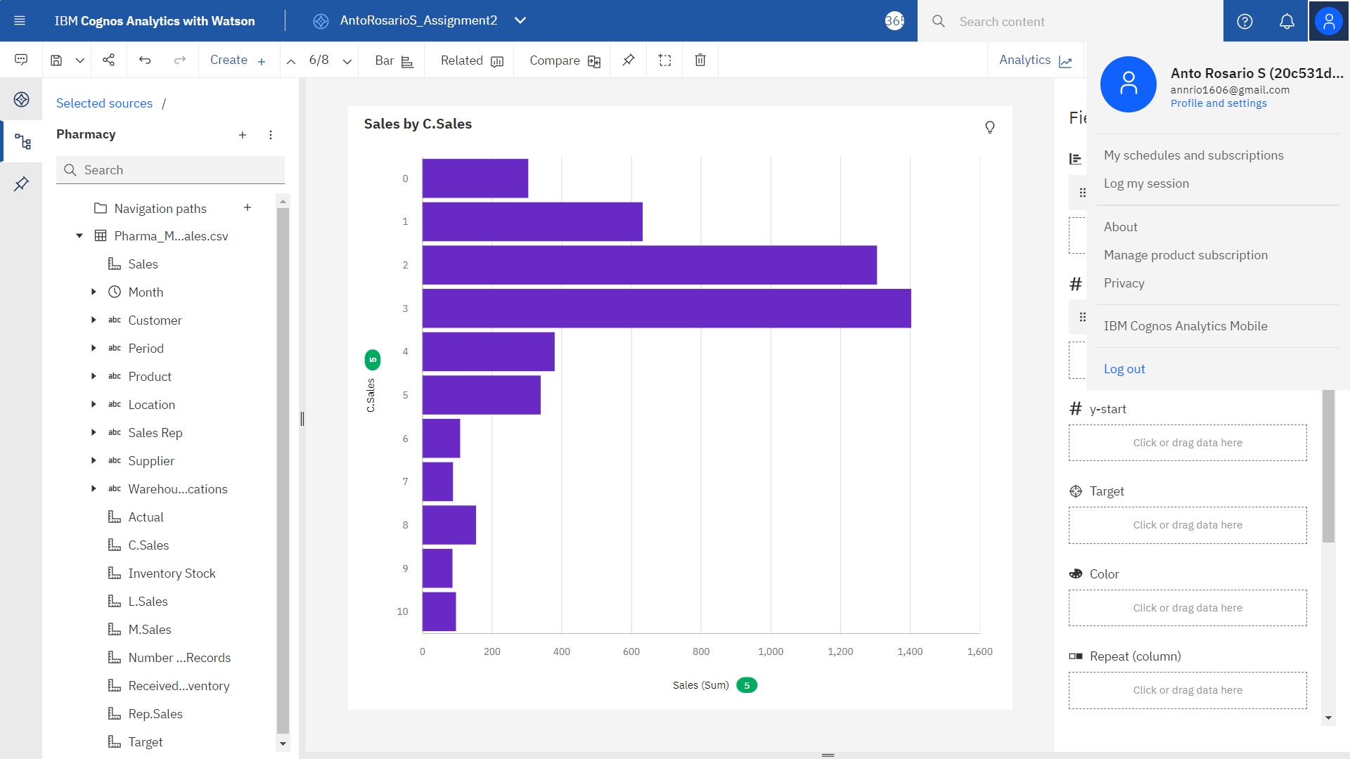

<https://us3.ca.analytics.ibm.com/bi/?perspective=explore&pathRef=.my_folders%2FAntoRosarioS_Assignment2&subView=model00000183ccfa1d11_00000004>

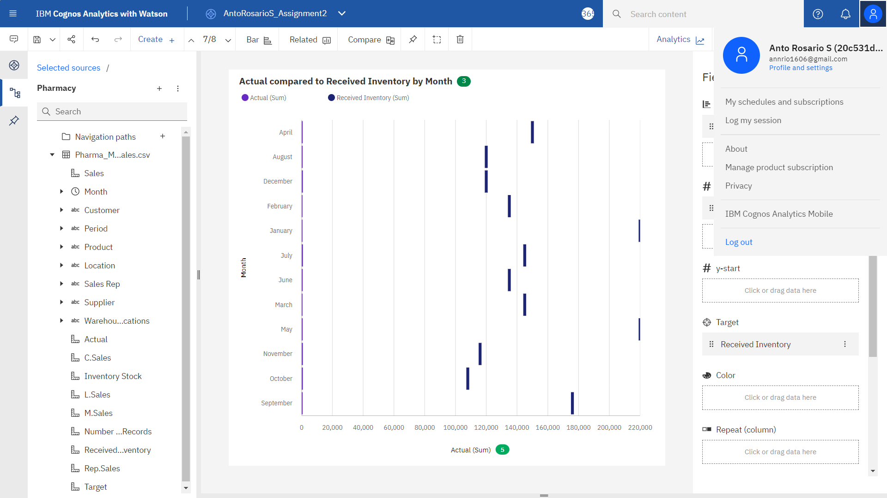

<https://us3.ca.analytics.ibm.com/bi/?perspective=explore&pathRef=.my_folders%2FAntoRosarioS_Assignment2&subView=model00000183ccfacb56_00000004>

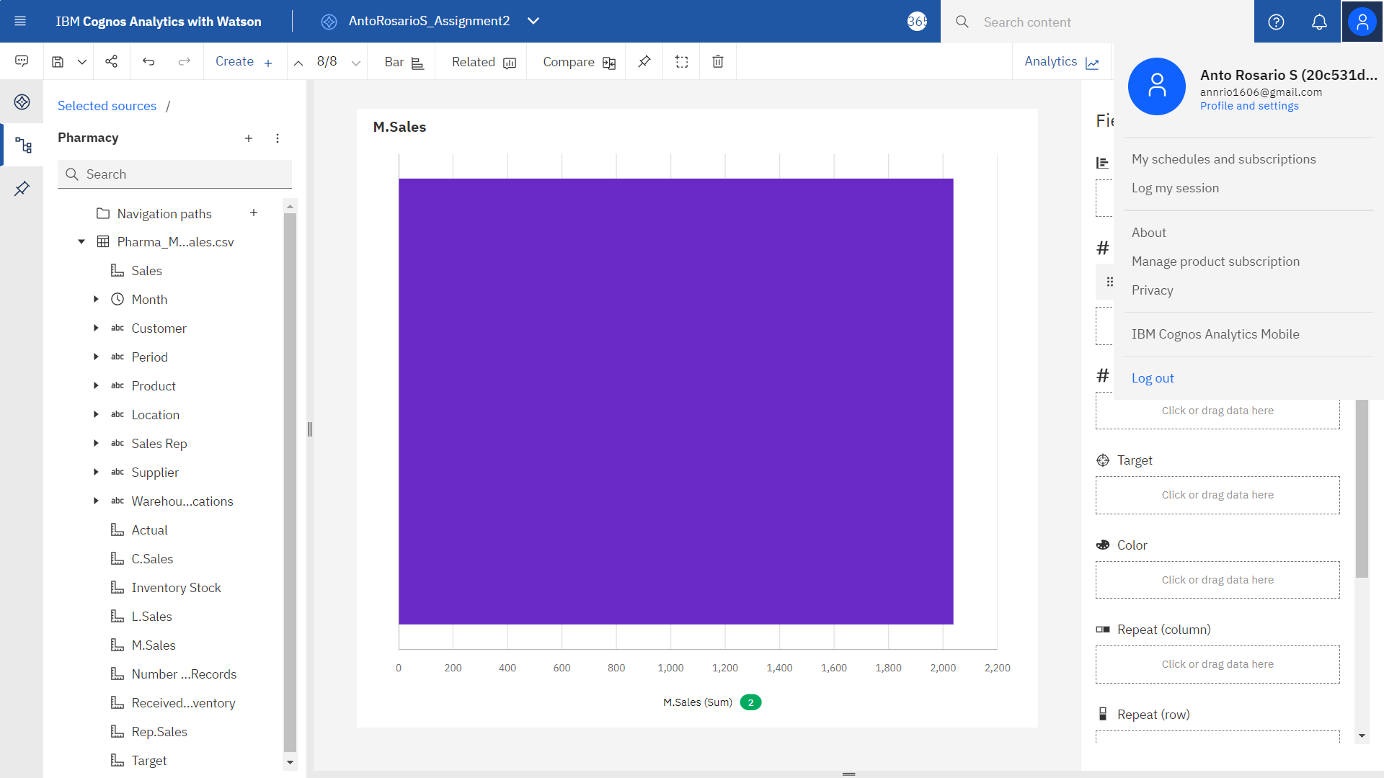

<https://us3.ca.analytics.ibm.com/bi/?perspective=explore&pathRef=.my_folders%2FAntoRosarioS_Assignment2&subView=model00000183ccfaed86_00000004>

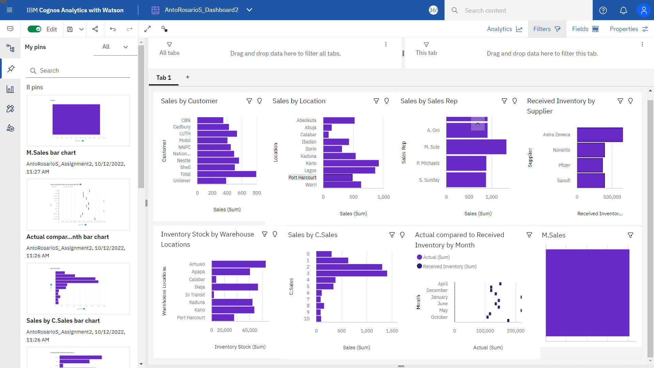

<https://us3.ca.analytics.ibm.com/bi/?perspective=dashboard&pathRef=.my_folders%2FAntoRosarioS_Dashboard2&action=view&mode=dashboard&subView=model00000183cd0c44d1_00000000>